# **Economics of Integrating Commodity Crops in Agrivoltaic Systems in the US Midwest**

Paul Mwebaze1, , Madhu Khanna1*, James McCall2,Fahd Majeed1, DK Lee1, Xuzhi Du1, Mengqi Jia1, Nenad Miljkovic1, Bin Peng1, Ruiqing Miao3, Kaiyu Guan1, Jordan Macknick2

1University of Illinois Urbana Champaign

2National Renewable Energy Laboratory (NREL)

3Auburn University

## Abstract

Declining costs of photovoltaic (PV) technology, rising market and policy incentives, and crop price fluctuations are leading to the growing deployment of PV on cropland in the US Midwest, leading to a potential conflict with food production. The dual-use of land, through Agrivoltaic (AV) technology that enables the co-location of PV energy and agricultural production on the same land, has the potential to reduce land use competition with row crops in the US Midwest. We develop a cost-benefit framework that considers the effects of solar panels on crop yields and various field designs and space and height requirements in AV systems to accommodate row crop production with conventional farm equipment and compares the net benefits of AV to those with stand-alone PV or crop production on a representative farm. The results show that utility-scale AV with corn and soybeans may increase land productivity, measured by a land equivalent ratio (LER) value greater than one. However, interspersing panels with crops is unlikely to be profitable compared to PV alone. We find that AV could be marginally profitable compared to crop production for a farmer but less profitable than leasing land for solar farming. These results highlight the challenge of commercializing AV with row crop farming without significant subsidies to developers to cover upfront capital costs.

*Keywords*: Agrivoltaics, agriculture, photovoltaics, land equivalent ratio, costs, benefits

*All correspondence should be addressed to Madhu Khanna, ACES Distinguished Professor and Alvin H. Baum Family Chair and Director, Institute for Sustainability, Energy and Environment, University of Illinois, Urbana-Champaign; email: khanna1@illinois.edu. We gratefully acknowledge funding from NIFA project grant number 2021-68012-35898.

## **Introduction**

Concerns about climate change mitigation are leading to growing interest in renewable energy and, together with declining costs of solar, are leading to a rapid increase in solar energy deployment in the United States (US). The share of solar is expected to grow from 3% of the US electricity supply in 2020 to 40% by 2035 and 45% by 2050 (U.S. Department of Energy 2021). Utility-scale solar is the fastest growing segment of solar energy deployment and is land-intensive, requiring 3–10 acres per MWdc of installed capacity (Ong et al., 2013; Bolinger and Bolinger, 2022). Utility-scale PV installations are expected to require 4 -11 million acres of land by 2050, depending on solar deployment scenarios (U.S. Department of Energy 2021).

Agricultural croplands coincide with areas favorable to solar energy deployment (Macknick et al., 2022), and they often have the highest productivity for Photovoltaic (PV) energy generation (Adeh et al., 2019). The available solar insolation, stable soil conditions, and inherently flat aspects of agricultural lands reduce project risks for solar developers (Macknick et al., 2022). Other characteristics of farms favorable for solar energy are nearby interconnection access to the electric grid, access to roads, and access to water for panel cleaning if needed (Macknick et al., 2022). This, together with the low and uncertain returns to crop farming and high land lease rates offered by PV developers, is leading to increasing conversion of cropland to solar farming (Walston et al., 2021). Declining costs of PV technology and rising market and policy incentives for solar energy have led PV developers to offer land lease rates that are three to four times higher than the low and uncertain returns to row crop production (Wyatt and Kristian, 2021; Bookwalter, 2019; Smith, 2022). Illinois is one of the fastest-growing states for solar deployment (Sorensen et al., 2022).[1]

This has led to concerns about solar farms displacing food production and community opposition to solar development, similar to those with wind energy, biofuels and oil and gas developments (Petrova, 2013; Thomas et al., 2017; Moore et al., 2021; Susskind et al., 2022)[2]. Many jurisdictions now prohibit large-scale solar farms on agricultural land (Wyatt and Kristian, 2021; SEIA, 2020; Sorensen et al., 2022).

Interest in maintaining access to cropland for solar farming is generating interest in Agrivoltaic (AV) technology for using land for both crop production and solar energy (Dupraz et al., 2011; Barron-Gafford et al., 2019; Mamun et al., 2022). There are various types of AV installations, ranging from planting pollinators, specialty crops, pasture grasses, and animal grazing sites. These differ in the requirements for spacing and height of panels, the shade tolerance of crops/grasses, and the need for equipment for planting and harvesting. Several studies have examined the effects of growing specialty crops in AV systems and shown that they can improve economic welfare for landowners/farmers and solar developers, provide valuable ecological services, and expand siting opportunities for solar deployment (Barron-Gafford et al., 2019; Hernandez et al., 2019; Gomez-Casanovas et al., 2023). However, there has been no assessment of the costs and benefits of AV with row crop systems in the US Midwest context.

The purpose of this study is to address several research objectives at the farm level. Firstly, it aims to assess the implications of AV for land productivity compared to PV or crops alone. The land equivalent ratio (LER) is widely used in the literature for analyzing the productivity of dual use of land (Dupraz et al., 2011; Weselek et al., 2019; Mamun et al., 2022; Gomez-Casanovas et al., 2023). LER is defined as the sum of the yield ratios of dual land use (AV systems) to mono land use (separate production of PV energy and crops) (Dupraz et al., 2011; Trommsdorff et al., 2021). AV systems create a tradeoff between the amount of solar radiation available for solar energy generation and the amount available for crop production. Increasing energy production by increasing solar panel density leads to crop shading impacts, which can lead to positive or negative crop production depending on the shade-tolerance of the crop (Barron-Gafford et al., 2019; Weselek et al., 2019, 2021).

Secondly, we examine the land requirements of AV compared to PV or crop production for producing per unit electricity or crop output to determine the extent to which it is land-saving. While AV can allow dual use of land to get two activities on the same land (crop and electricity production), in practice, crops cannot be grown under panels without making the panels extremely tall and very expensive. Instead, crops must be grown between panels, and a buffer area is needed between panels and crops to allow for equipment movement without damaging the panels (Feuerbacher et al., 2021). As a result, there is unused land in an AV system that was being used productively in a PV alone or crops alone field.

Thirdly, we quantify the profitability of AV compared to PV alone or crop production alone for a representative field. We analyze the extent to which lower vegetation management costs and land lease costs for solar developers and net revenue from crop production compensate for higher panel costs. We also analyze the profitability of AV relative to crop production alone and relative to leasing the land for PV generation. We analyze conditions under which AV can be profitable for farmers and solar developers and the breakeven price of panels in an AV system, which will make it just as profitable as PV alone for solar developers.

We address these objectives using a benefit-cost analysis (BCA) approach (Boardman et al., 2018), combining engineering and crop models and incorporating economic analyses. We develop scenarios to integrate corn and soybean production into an AV design for a representative farm and compare the outcomes. The study is conducted over 25 years to reflect the lifetime of the PV system. We account for the timing of benefits and costs by discounting them to their net present values (NPV) and assessing the annual profit of the combined system.

Some studies on AV systems in other countries show that they negatively affect corn and soybean yields (Sekiyama and Nagashima, 2019; Bhandari et al., 2021; Campana et al., 2021). One study in the US suggested that systems with elevated PV panels that allow for crop production underneath them can increase energy production with minimal impact on corn production (Turnley et al., 2022). A comprehensive understanding of the shading effects between solar energy systems and corn and soybean production is lacking under current climate conditions in the US Midwest.

Many studies indicate that most AV systems result in LER values greater than 1, meaning a greater land use efficiency (Amaducci et al., 2018; Dupraz et al., 2011; Trommsdorff et al., 2021; Toledo and Scognamiglio, 2021; Schweiger and Pataczek, 2023). However, if profitability is a driver of AV adoption, a comparison of profit for AV is needed with separate PV and crop production. Only one study has scrutinized the relationship between LER and the profitability of AV. Sojib Ahmed et al. (2022) emphasize using profitability and not the LER as the appropriate performance indicator of AV systems in rice production. This paper aims to examine further whether a high LER measures productivity and how it correlates with profitability.

Moreover, few studies have holistically examined the profitability – costs and benefits – of AV systems compared to crops or solar-only options; most reports focus on specialty crops, and there is very little literature on row crops. Several studies find higher profits than crops only for AV systems with specialty crops such as lettuce, basil, spinach and other vegetables (Dinesh and Pearce, 2016; Mavani et al., 2019; Thompson et al., 2020). The higher profits reported in these studies result from the additional energy revenues compared to a crop-only system and increased yields of shade-tolerant crops (Mamun et al., 2022). In the case of row crops, studies with cereal farming systems in Germany (Feuerbacher et al., 2021, 2022) and rice farming across six countries (Vietnam, Bangladesh, China, Egypt, Brazil and India) (Sojib Ahmed et al., 2022) find that crop yields decline substantially in an AV system relative to crops alone and that electricity prices for an AV system would need to be significantly higher than for a PV system to make AV profitable.

This study makes two contributions to literature. Firstly, this study combines a crop model with an engineering and economic analysis to examine the effects of shading on crop yields and the profitability of AV under various space-height configurations in the US Midwestern region, where soybean and corn production are dominant. Secondly, we investigate the relationship between the LER and profitability to examine whether the productivity-enhancing rationale for AV is consistent with economic incentives for adopting AV by private developers and landowners. The rest of the paper is organized as follows. The next section describes the methods and data used for the study.Results and discussions follow, and the last section presents the conclusions.

## **Methods**

### *2.1 Impact of solar on yields*

Changes in crop yields due to shading under AV conditions were estimated using a crop simulation model. The crop (soybean) model was developed based on the Agricultural Production Systems Simulator (APSIM) Soybean Model (Archontoulis et al., 2014; Brown et al., 2014). The APSIM soybean model is designed to predict crop growth and development under diverse environmental conditions and management practices. The model was simplified to integrate solar generation and predict crop yields under AV conditions. In this context, soybean yield under AV conditions was determined as a function of key variables, including the intercepted solar radiation, radiation use efficiency, and harvest index (See supplementary for more details of the crop model). We conducted a comprehensive validation of the soybean model utilizing historical soybean yields (from 2016 to 2022) from geographically distinct locations in the US. The results showed a high level of agreement between the predictions of the soybean model and the actual historical field data from the USDA statistics (USDA NASS 2024), as shown in Supplementary Figures 1f-h.

### *2.2 Benefit-cost analysis*

We develop a conceptual framework to compare the profitability of AV with stand-alone PV and crops for a representative field. We assume that solar developers and farmers/landowners choose the production system that returns the highest discounted profit per unit of land. A profit-maximizing solar developer is assumed to adopt an AV system if it increases the net present value of returns per unit of land compared to PV alone. A farmer is expected to adopt an AV system if it increases its net returns to land compared to crops alone and compared to leasing land for solar farming. We consider the following two cases for managing an AV system:

Case 1: Solar Developer Manages Solar Generation and Farmer Manages Crop Production

We suppose that the solar developer and farmer each care only about their profits per unit of the land they manage. The developer pays rent only for the non-cropped portion of the land, and the farmer is responsible for managing vegetation cover on that portion.

Suppose that the solar developers adopt AV with a given space-height configuration if the profit per acre from AV is larger than or equal to the profit per acre from PV (Equation 1). AV adoption involves higher capital costs per acre due to the need to raise panel height, offset by lower vegetation management costs and partial land rental payments. Furthermore, depending on the density and capacity of the transmission network, AV can increase transmission costs relative to PV. The potential loss in profits with AV compared to PV represents the subsidy needed as an investment and production tax credit to make AV competitive with PV. The average annual profit per acre for the solar developer can be expressed in Equations (2) - (3) as follows:

(1)

(2)

(3)

where: is the annualized profit of AV per unit of land ($/acre) for the solar developer; is the annualized profit of the solar-only system per unit of land for the solar developer ($/acre); is the proportion of the land allocated to solar panels while the share under crop production is the remainder(); is the price of electricity from the solar PV ($/MWh); is the solar energy output from the PV portion (MWh/year); *R* is the solar renewable energy credit ($/MWh); is the levelized cost of solar energy under PV only ($/MWh) while is the levelized cost of solar energy under AV ($/MWh); and *L* is the fixed rental rate per acre per year ($/acre). is the impact on energy yield under AV conditions. Appendix 1 provides more details for calculating the LCOE of the PV and AV systems.

Suppose the farmer adopts AV if the profit per acre from AV exceeds the profit from leasing land for PV alone and the profit per acre from crop production alone (Equation 4). With AV, farmers can receive higher rent for PV production on the leased portion of the land. However, AV systems create negative yield impacts on the cultivated portion of the fields due to partial shading (Valle et al., 2017; Sekiyama and Nagashima, 2019). Furthermore, there is a loss of land underneath panels that cannot be farmed. The loss in profits with AV compared to PV for the farmer will be the subsidy needed for the farmer to adopt AV as a conservation program payment. Farm profitability is the revenue after variable and fixed costs are deducted from the total revenue (Equations 5/6).

(4)

(5)

(6)

where: is the annualized profit of the crop portion per unit of land ($/acre) for the farmer; is the per acre profit of the crop-only system ($/acre); *L* is the fixed rental rate per acre per year ($/acre); is crop price of output ($/bushels); is crop yield from the AV system in full sunshine (bushels/acre); is the impact on crop yield from the shading effect due to the solar panels; and are variable cost ($/bushels) and fixed costs ($/acre), respectively.

Case 2: Profit Sharing by Developer and Farmer

The third perspective is profit sharing by the solar developer and farmer. Suppose the landowner is also the PV producer and crop producer. In that case, they will adopt AV if the combined profit from solar under AV and crops under AV exceeds profits from PV and crop production separately (Equation 7). The solar producer may be worse off, but if the farmer is substantially better off with AV, such that they are better off together, then AV will be adopted.

(7)

(8)

where: is the combined annual profit of solar and crops under AV per unit of land ($/acre); all other terms are as previously defined. We estimate the profits with a corn-soybean rotation under the crop-only scenario to compare a continuous soybean rotation with AV.

### *2.3 LER and Profitability*

To better understand the adoption potential of AV, we also need to incorporate AV’s land use efficiency gains (LER) into the profit function relative to that of solar and crop-only options to determine the profitability conditions for AV. The LER is formally defined in Equation (9):

(9)

where *Y* is the crop yield, *S* is the energy yield, and is the share of land allocated to solar panels. An LER >1 indicates an increase in productivity of the AV system compared to PV only or crop only system (Amaducci et al., 2018; Weselek et al., 2019; Gomez-Casanovas et al., 2023).

For simplicity, we can assume that AV yield is proportional to mono-cropping and PV systems, leading to Equation (10).

(10)

where 𝛿𝑃𝑉 and 𝛿𝐶 represent the impacts on energy and crop yield under AV conditions, and all other terms are as previously defined. The yield terms cancel out, giving the reduced form LER expression in Equation (11):

(11)

Using this expression, we can re-arrange terms to isolate the crop shading impact () term and substitute the result into the profit function to identify higher or lower profitability conditions for AV. Substituting this expression for into the profit equation yields Equation (12), which shows the components and determinants of AV profitability incorporating the LER.

(12)

Finally, the expression can be further simplified by rearranging terms as given in Equation (13):

(13)

Equation (13) highlights the conditions for AV profitability. The magnitude and signs of the components of profitability depend on the PV production and crop yields. Solar energy production will occur on less land under AV scenarios (), and the variable costs are higher than the solar-only option. This implies that profitability depends on whether the gains in crop yield more than offset the capital and operating costs of the AV system. Profitability also depends on whether the reduction in solar revenue is compensated by the additional crop revenue, implying high crop yields and prices. LER can be one or higher, while profitability is positive, zero or negative. Even if LER exceeds 1, one can still get negative profits. We examine three cases below to show this:

Case 1: suppose that and , meaning no negative effects on energy yield. If (solar PV only), then by assumption. This implies that .

Case 2: If (crop only), then, by assumption, . This implies that .

Case 3: If and . Based on the literature, we can assume an average LER of 1.5 (Gomez-Casanovas et al., 2023). In this case, the AV profit can be simplified to:

Note that the energy profit is reduced by half while the crop profit term is a relatively small share. This implies a reduction in the AV profit compared to PV only: .

### *2.2 Description of AV Scenarios*

We developed several scenarios to explore the trade-offs between electricity production and crops in AV systems. Regarding the design configuration, panel heights and row spacing can affect the type of crops produced, available solar radiation, compatibility with farm equipment, AV costs, and returns (Macknick et al., 2022). In a standard PV system, the distance between panels is about 15-18 ft to prevent the panels from shading each other (Dupraz et al., 2011). Given a fixed amount of land (e.g., an 80-hectare farm, the average farm size in Illinois), this configuration leads to 70-panel rows to maintain the minimum space between panels. By contrast, there are many different ways to configure an AV field. One way of installing AV in a manner compatible with conventional corn/soy rotational farming equipment and practices is depicted in Figure 1. This approach leads to areas with full sun, partial sun and shading. This design may not be an optimal field design for agricultural operations, depending on the yield impacts of shading and how much land is unusable due to PV equipment. Depending on the solar configuration and local climate, there may not be sufficient solar radiation to allow for the cultivation of different crops. Furthermore, solar panels may need to be raised to an elevation compatible with standard machinery for crop production to allow for mechanical cultivation and avoid shading of the solar panels by the crops. The higher capital costs reflect the cost of installing a structure supporting PV panels at that height. This configuration can add 20-30% to the total installation cost of solar (Ramasamy et al., 2022), but it may be much higher depending on design and market conditions.

To examine the profitability of AV systems, we defined several AV scenarios by varying the design configurations and field geometry of a “representative” hypothetical AV farm. Table 1 describes the scenarios in detail. Scenarios 1, 4 and 8 represent our core AV scenarios, while the rest are variations of the reference scenario included for comparison and sensitivity (Table 1). We then constructed an 80-acre hypothetical farm, Illinois's average farm size (USDA NASS, 2024). The initial design configuration of the AV farm was based on the dimensions of standard farm equipment depicted in Figure 1, with a row spacing of 43.5 ft and a height of 8ft. This is the “reference” AV scenario (Figure 1). This illustration assumes that a tractor needs 10 feet of space and the buffer is 30 feet. We constructed several comparison scenarios to investigate the choices affecting profitability (See Table 2 for details). Figure 2 shows the geometry of the AV reference and comparison scenarios. Furthermore, shading impact is also a key factor influencing PV and crop yields. We utilized a crop simulation model to estimate the impact of shading on corn and soybean yields in the AV scenarios (see Appendix 1 for more details). We then model and calculate profitability for the different scenarios incorporating shading impacts (Table 2).

Table 1: Scenarios

|  |  |  |
| --- | --- | --- |
| Scenario | Short name | Scenario description |
| *Core scenarios* |  |  |
| 1 | AV reference | * The AV reference refers to ground-mounted/elevated PV panels with the area between them used for farming. The spacing between the PV panels has been increased compared to the standard PV to allow standard-sized farming equipment to pass between the rows. |
| 4 | Automated | * We take the reference AV scenario and reduce the farming buffer to show the impact of increasing crops in AV. This is similar to a PV system designed for farming. It reflects the use of automated farm equipment to reduce human error in the future. |
| 8 | Optimistic | * Utility-scale farming under panels, farming all available land, night farming/stowing panels, and automated equipment. This is the best-case scenario where we can farm all available areas because of technological advancements, but it comes with higher capital costs. We include it as a future scenario. |
| *Comparison scenarios* |  |  |
| 2 | AV medium PV density | * AV reference with a medium PV density. * We increase PV density and reduce the farming area to show which component (PV or crop density) has a bigger impact on profitability. |
| 3 | AV high PV density | * AV Reference with high PV density. * Similar to scenario 2, we increase PV density and reduce the farming area to show whether PV or crop density has a bigger impact on profitability. |
| 6 | Raised | * AV Reference with raised panels. * The panels are raised to allow more sunlight to reach the crops and to make it easier to run machinery, making it more farmer-friendly. |
| 9 | Reference buffer farming | * AV reference with farming in buffer. This is the AV reference scenario with solar and crops on the same land but not integrated. |
| 5 | Ag/PV split | * Split crops and utility PV on either side of the field. This scenario, having the two side by side, is included for comparison and sensitivity analysis. * It is a blend of PV and crops only. |
| 10 | PV Control | * Utility-scale PV. |
| 11 | Ag Control | * Crops only. |

Table 2: Description of the scenarios for AV design configurations

|  |  |  |  |  |  |  |  |
| --- | --- | --- | --- | --- | --- | --- | --- |
| Scenario | Short description | Spacing (ft.) | Height (ft.) | Crop area (acres) | PV area (acres) | PV capacity (MW) | CAPEX ($/W) |
| 1 | AV reference | 43.5 | 8 | 45.82 | 34.18 | 10.36 | 2.66 |
| 2 | AV medium PV density | 33.5 | 8 | 40.36 | 39.64 | 13.69 | 2.66 |
| 3 | AV high PV density | 23.5 | 8 | 28.91 | 51.09 | 19.61 | 2.66 |
| 4 | Automated | 43.5 | 8 | 61.09 | 18.91 | 10.36 | 2.66 |
| 5 | Ag/PV split | 18 | 4 | 53.37 | 26.63 | 10.36 | 1.15 |
| 6 | Raised\ | 43.50 | 12 | 53.37 | 26.63 | 10.36 | 3.06 |
| 7 | Raised half shade | 43.5 | 12 | 45.82 | 34.18 | 5.18 | 3.06 |
| 8 | Optimistic | 18 | 12 | 74.5 | 5.9 | 25.90 | 3.06 |
| 9 | Reference buffer farming | 43.5 | 8 | 51.19 | 28.81 | 10.36 | 2.66 |
| 10 | PV Control | 18 | 4 | 0 | 80.0 | 25.90 | 1.15 |
| 11 | Ag Control | 0 | 0 | 80 | 0.0 | 0.0 | 0.0 |

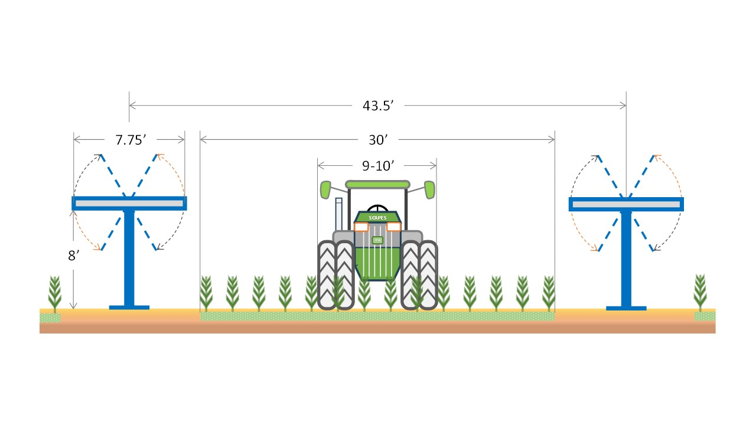

Figure 1: AV reference scenario showing ground-mounted/elevated PV modules with the area between the panels used for farming. The spacing between the PV modules has been increased to allow standard-sized farming equipment to pass between the rows. There is a 30 cm buffer, and we are not farming up to the edge of the panels to avoid damage to the PV panels.

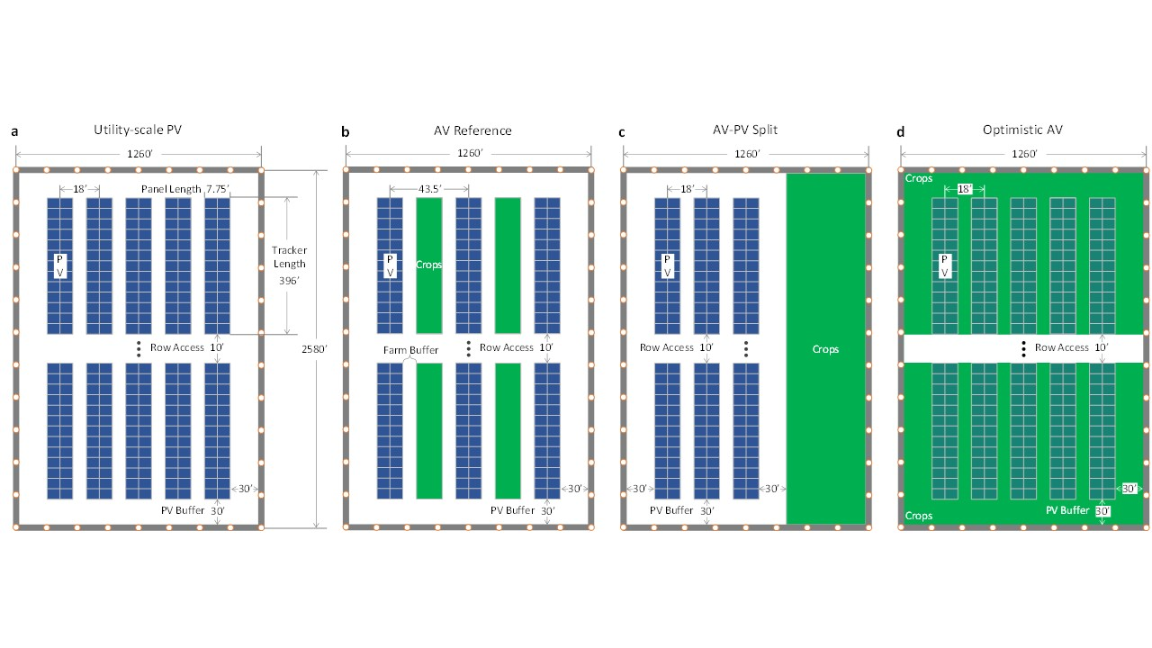

Figure 2: AV reference and comparison Scenarios

### *2.3 Data*

The AV scenarios were modelled to study crop and energy output per acre of farmland at a representative farm in Champaign County, Illinois (Latitude/Longitude: 40.13, -88.22). Table 3 presents an overview of the model parameters of the AV scenarios. Data on technology parameters describing the AV scenarios are primarily from the National Renewable Energy Laboratory (NREL) reports (Horowitz et al., 2020; Ramasamy et al., 2022). The NREL System Advisor Model (SAM) was used to calculate the energy output of the AV/PV system (SAM 2023). The SAM model is a techno-economic software tool that estimates electricity generation and the LCOE at a single point. The capacity of the AV scenarios, area under PV and crops, and investment costs vary by the spacing-height combination of the scenarios. We assume the AV system has a lifetime of 25 years with a degradation rate of 0.5% per year and annual operating expenses (OPEX) of $15 per kW (Table 2). Since AV systems require elevated PV panels to accommodate crop production, capital costs (CAPEX) for AV increase significantly compared to ground-mounted PV (Shindele et al., 2020); this translated to a CAPEX of $2.66/W for 8-foot tall panels and $3.06/W for 12-foot tall panels compared to $1.15/W for conventional PV systems (Ramasamy et al., 2022). Further, we used a current discount rate of 6.5%/year to calculate the LCOE consistent with recommended guidelines that vary between 6%/year and 8%/year (Burgess and Zerbe, 2015), with alternative values used to test for sensitivity analysis (Boardman et al., 2018). Data on changes in crop yields due to shading under AV conditions were obtained through a simulation model (see Appendix 1). In the Midwest, most farmers practice corn-soybean rotations. For simplicity, we simulated continuous soybean production throughout the year under AV. These data were combined and merged with data on production costs, crop prices, solar energy prices, and renewable energy incentives to calculate the profitability of AV scenarios (Table 3).

Table 3: List of model parameters of the AV system

|  |  |  |  |  |
| --- | --- | --- | --- | --- |
| Parameters | Variable | Units | Value | Source |
| *Solar Component* |  |  |  |  |
| Solar generation | *S* | kWh/kW | 1650 | SAM (2023) |
| Expected lifetime of PV/AV system | *T* | Years | 25 | SAM (2023) |
| Reduction in module efficiency | *d* | %/year | 0.5 | SAM (2023) |
| Real discount rate | *r* | %/year | 6.5 | SAM (2023) |
| Inflation rate | *I* | %/year | 0 |  |
| Utility-scale capital cost (CAPEX) | *k1* | $/W | 1.15 | Ramasamy et al. (2022) |
| Raised panel capital cost (CAPEX) at 8 ft. | *k2* | $/W | 2.66 | Ramasamy et al. (2022) |
| Raised panel capital cost (CAPEX) at 12 ft. | *k3* | $/W | 3.06 | Ramasamy et al. (2022) |
| Operational costs (OPEX) | O | $/kW-yr | 15 | Ramasamy et al. (2022) |
| Transmission costs | M | $/MWh | 3.67 | Maclaurin et al. (2021) |
| Land Lease | *L* | $/acre-yr | 1000 | Est. from Solar Industry |
| Electricity (PPA) Price |  | $/MWh | 75.7 | LBNL (2023) |
| Renewable Energy Credit (REC) | *R* | $/MWh | 6.60 | NREL 2021 |
| *Agricultural component* |  |  |  |  |
| Soybean yield |  | Bushels/acre | 58.24 | USDA NASS |
| Soybean price |  | $/Bushels | 9.69 | USDA NASS |
| Soybean Variable Cost |  | $/Bushels | 2.5 | USDA NASS |
| Soybean Fixed Cost |  | $/acre | 136 | USDA NASS |

Notes: CAPEX is capital expenditures, while OPEX is the operating expenditures.

**Results and Discussion**

### *Effect of AV on crop yield and energy generation*

Differences in crop yields were found across AV scenarios. Crop yields per cropped acre in AV scenarios were significantly lower (by 17% and 53% in AV reference and AV optimistic, respectively) than in scenarios under crop production alone (Figure 3). These results are consistent with the literature, which shows that AV systems can negatively affect the yields of similar crops by shading (Campana et al., 2021; Gonocruz et al., 2021; Weselek et al., 2021). These findings suggest that yield reductions for row crops are likely under AV systems, depending on the configurations.

By contrast, energy generation in AV scenarios was slightly higher (by 11% and 4% in AV reference and AV optimistic) than in scenarios under PV only (Figure 4). While this result could be attributed to differences in the configurations (panel height) and improved power-generating conditions under AV, we did not account for any microclimate impacts in the simulation model. However, similar results have been reported in the literature. Barron-Garfford et al. (2019) found that panel temperature in AV settings in the arid southwest region of the US was about 9C cooler than conventional PV, leading to 2% annual enhanced PV generation. From a study in Ontario, Canada, Williams et al. (2023) showed that AV mounted at 4m with soybeans underneath exhibits solar module temperature reductions of up to 10C compared to a PV farm mounted at 0.5m over bare ground. These results indicate that ground conditions and panel height play important roles in solar farm cooling and improving solar PV conversion efficiency.



Figure 3: Yield per cropped acre (bushels/acre)



Figure 4: Output per capacity installed for each scenario (MWh/ Yr).

### *3.2 Comparing Alternative Configurations of AV Systems*

To better understand the cost tradeoffs of AV configurations, we compared the capacity and total costs of the AV scenarios (Figures 5 and 6). The results show that the AV optimistic scenario has the same energy capacity as the utility-scale PV but at more than double the cost. Similarly, the AV reference scenario has the same energy capacity as the Ag/PV split but with twice the cost. These results indicate that AV scenarios cost more for the same energy capacity as utility-scale PV. They highlight that AV configuration cost is much higher than utility-scale PV across all scenarios. Furthermore, the results show that the most significant cost component is the annual CAPEX (Figure 6), highlighting the cost of potentially elevating the PV panels (Ramasamy et al., 2022). The results are consistent with estimates reported in the literature. The LCOE of AV systems is about 38% higher than that of a traditional, ground-mounted solar PV installation (Schindele et al., 2021). While the operational costs are similar to those of PV, the overall capital costs for installation are 30% or higher for AV systems (Schindele et al., 2021).

To further explore tradeoffs among the AV configurations, we calculated the LER, an important measure of the total land productivity of AV systems. Previous studies show that AV systems generate LER greater than 1, indicating a higher land use efficiency (Amaducci et al., 2018; Dupraz et al., 2011). Figure 7 shows the LER for the AV/PV scenarios. As expected, several AV scenarios have LER greater than 1. The AV optimistic and high PV density scenarios both have reduced crop yields but with increased solar generating potential leading to LER>1. Three AV scenarios have LER less than 1. The AV reference, medium PV density, and reference with buffer farming have reduced crop yields due to shading and lower solar energy potential, leading to LER<1 (Figure 7).

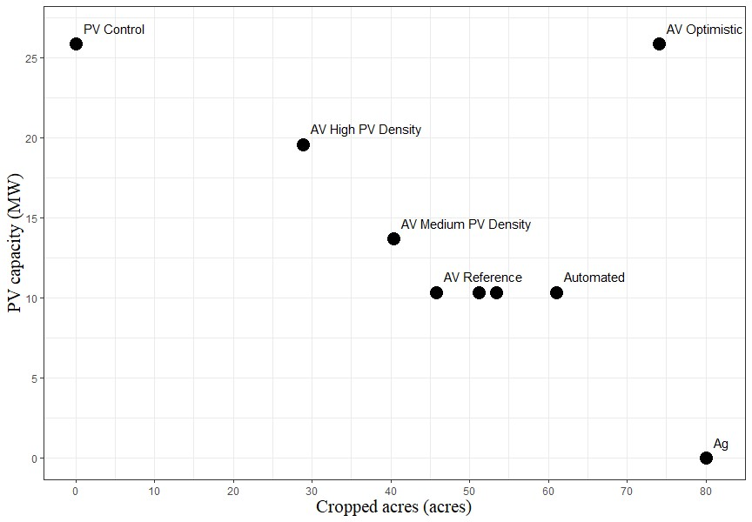

Figure 5: Nameplate capacity and cropped acres trade-off



Figure 6: Annualized total costs of PV and AV (80-acre field).

These results are in agreement with the literature. Sekiyama and Nagashima (2019) reported that corn yields under low-density PV panels were increased, implying high LER, while those under high-density PV panels were moderately lower (meaning low LER). A study by Trommsdorff et al. (2021) reported a mean LER value of 1.7 for winter wheat for AV systems in Germany. Other studies have found that crop yields may increase or decline due to shading with AVs (Weselek et al., 2019, 2021) but that LER can be as much as 70% higher (LER = 1.7), indicating substantial overall productivity increases compared to crop alone or stand-alone PV (Gomez-Casanovas et al., 2023). Ultimately, just like any PV system or farming system, the feasibility of an AV system will be determined by its overall profitability. We discuss the profitability of AV in the next section.

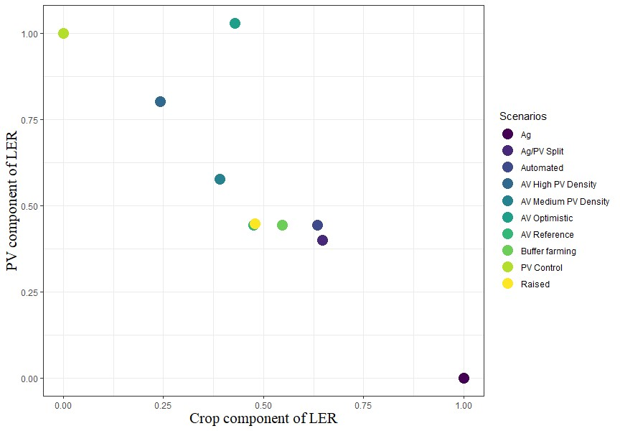

Figure 7: LER tradeoff in AV scenarios

### *3.3 Profitability of AV Configurations*

We calculated the costs and returns for the AV scenarios to determine AV's profitability and adoption potential at the farm level (Figure 8). The results suggest that most AV scenarios are not profitable. The Ag/PV split is better than the AV reference but less than PV alone. There were no AV configurations with higher profits than PV alone. Furthermore, the results show that the CAPEX dominates revenues in most AV scenarios. In several cases, the AV configurations are not economically viable compared to conventional crops. There are currently few studies of AV systems with row crops against which to compare these results. One study by Feuerbacher et al. (2021) showed that profitability depends on PV parameters. They predicted that cereal farming systems in Southern Germany could adopt AV at a tariff of €86.3/MWh (equivalent to $94.5/MWh at the current exchange rate), implying higher PPA prices than used in our analysis ($75.7/MWh).



Figure 8: Annualized Costs and Benefits of PV and AV for the 80-acre field.

### *3.4 Distribution of returns from crops, AV and PV*

To explore the distribution of profits, we examined farmer returns from crops, AV and PV (Figure 9). The earnings from leasing land to PV ($80,000, assuming a $1000/acre lease payment) are higher (about $30,000 more annually) than crops alone ($49,100,000). This is consistent with other reports that income from solar leasing exceeds the returns generated by crop yields (Bookwalter, 2019). Interestingly, the profits from AV are greater than crop production alone for the farmer but less than PV alone. Furthermore, the Ag/PV split design is preferable to AV Reference by farmers. The AV optimistic scenario is close in profitability to leasing land to PV alone for the farmer. A dilemma arises with AV: the most profitable option for AV from the farmer’s perspective is the least preferable from the solar developer’s perspective. The fact that AV is profitable for farmers but not for solar developers underscores the need for potential policy support to address the additional costs associated with AV development and see the industry adopt these solutions.



Figure 9: Annual farmer profits from crops and land lease for the 80-acre field.

Instead of profitability, the LER is widely used in the literature to indicate AV performance. To examine the relationship between LER and the profitability of AV systems, we calculated the net returns from solar and crops on land and compared it with the LER (Figure 10). The results show that AV scenarios may result in higher LER but also have lower LER in some instances. There are several cases when LER>1 and AV seems viable. The highest LER is 1.5 in the AV optimistic scenario, while the lowest LER is 0.92 in the AV reference scenario. This implies that the AV optimistic scenario can achieve an additional 46% productivity while the AV high PV density and Ag/PV split scenarios provide an extra 5% productivity. However, as Figure 11 shows, an LER value greater than one does not imply higher profitability of AV or lower land requirements to obtain similar amounts of crops or solar generation. AV scenarios can have a high LER even with negative profits. This implies that LER greater than 1 is a misleading metric.

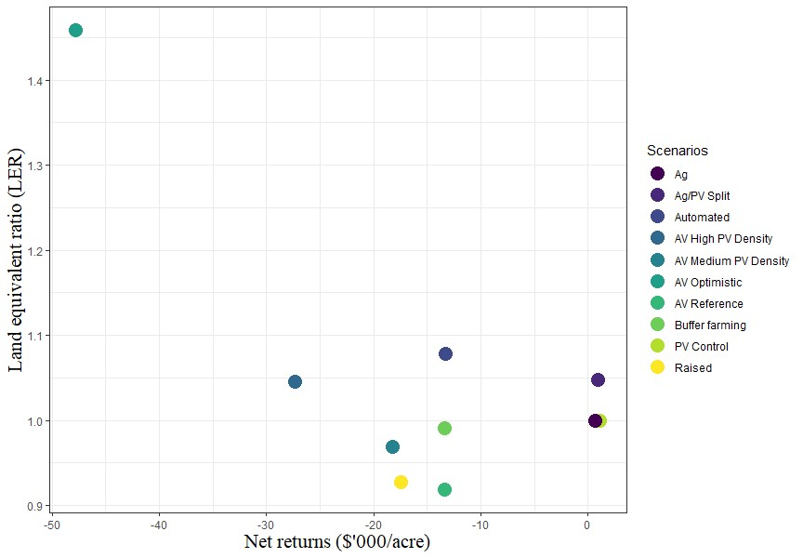

Figure 10: LER compared to annual net returns for the 80-acre field

### *3.5 Sensitivity Analysis*

We conducted several sensitivity analyses to examine the impact of variations in economic factors on the profitability of AV systems. The main economic factors of interest were the upfront investment costs, operational costs, electricity price, and the discount rate. To illustrate the impact of capital cost (CAPEX) on profitability, we calculated the breakeven CAPEX to make AV as profitable as PV alone (Figure 11). To achieve the same profits per acre as utility-scale PV, the CAPEX would need to be significantly lower than current estimates and even 15% lower than PV alone. The subsidy required for the AV optimistic design compared to utility-scale PV is approximately $3.92 million (for an 80-acre field). This result highlights the need for potential policy support to address the additional costs associated with AV development and see the industry adopt these solutions. A similar analysis in Germany found that implementing AV would require substantial policy support, amounting to a total annual subsidy of €1.18 billion, equivalent to an annual per hectare subsidy of about €13,852 (Feuerbacher et al., 2022).

To illustrate the impact of electricity price on profitability, we also calculated the breakeven electricity price to make AV profitable for solar developers with and without the REC (Figure 12). This shows that electricity price has a significant impact on profitability. To make AV profitable for solar developers, the price of electricity would need to be significantly higher than the current price and almost double in most AV scenarios. Similarly, we examined what happens if the farmer takes on the vegetation management and reduces O&M costs to zero. Vegetation management costs are a small fraction of the cost of raising panels. Furthermore, increasing the discount rate by 2-3% does not impact the results.



Figure 11: Breakeven CAPEX: AV as profitable as PV ($/W).



Figure 12: Breakeven electricity price to make AV profitable for solar developers

## **Conclusions**

Agrivoltaics (AV), the co-location of PV energy and agricultural production, can potentially reduce land use competition while increasing productivity by combining agricultural practices at solar sites. However, few studies have wholistically examined the costs and benefits of AV systems for row crops in the US. This study provides a novel conceptual framework to analyze the economics of row crop AV systems from a farmer and PV developer perspective and compare these systems to separate food and energy production systems at a representative farm in the mid-western US. Our key results show that utility-scale agrivoltaics with corn and soybeans are unlikely to be profitable compared to traditional PV under the current climate, policy conditions, cost, and land availability. The high costs of raising panels for agrivoltaics and giving up land from high-value solar to low-value crops is an economic barrier to investment in agrivoltaics. For solar developers, the capital cost of AV systems and the requirements for elevated panels to accommodate row crop farming equipment represent a potential constraint to broader adoption. Converting land from low-value crops to high-value solar is economically attractive for farmers. Still, agrivoltaics can help to meet other interests in diversification, keeping land partially in farming and ecosystem services.

However, AV could still be feasible in other farming circumstances. Firstly, AV systems could be appealing with high-value crops where returns to land are comparable to solar generation. For example, Thompson et al. (2020) reported 2.5% and 35% economic returns for basil and spinach, respectively, in Italy. Dinesh and Pearce (2016) found 30% more profitability from AV than conventional lettuce farming in the US. Secondly, it could be appealing for non-economic reasons—such as mitigating community opposition, optimal site locations, reputation and image of utility, and regulatory requirements. A survey by Pascaris et al. (2022) found that about 82% of respondents would be more likely to support solar development in their community if it was integrated with agricultural production. The increase in support for solar energy, given the agrivoltaics approach, highlighted a development strategy to improve local social acceptance and deployment of solar energy on agricultural land. Thirdly, AV could be feasible if supported with large agricultural land preservation payments, although a split crop and PV model would be preferable to an interspersed model. A study in Germany estimated that realizing the potential of AV would come at a substantial cost in terms of policy support, given that a total annual subsidy of €1.18 billion, equivalent to an annual per hectare subsidy of €13,852, is required to support AV adoption (Feuerbacher et al., 2022). Fourthly, AV will likely appeal to farmers interested in preserving a lifestyle instead of leasing land to solar farming. AV systems with higher energy-generating capacity are economically feasible in arid, moisture-stressed environments (Barron-Gafford et al., 2019). Smaller installations appear profitable with speciality crops under favourable conditions (Trommsdorf et al., 2020). AV may be feasible with short crops and vegetables that can be grown under panels without requiring major changes due to equipment. Agrivoltaics are more likely to be profitable in arid regions, with extreme temperatures and high-value crops that do not require heavy farm equipment.

The LER, which increases to > 1 on average in AV systems compared with crop or PV systems alone, is an important measure of the total land productivity of these systems. However, other economic factors, such as the relative price of crops and electricity, which are not accounted for in the LER, may drive declines in the profitability of AV despite a greater LER. Our results showed that a value greater than one does not imply higher profitability of AV or lower land requirements to obtain similar amounts of crops or solar generation. AV configurations can have a high LER even with negative profits. Thus, if LER does not mean higher profitability of AV, then farmers may not adopt it if they care about profits. We find that the LER>1 is a misleading metric. Compared with PV or crops alone, the adoption of AV will depend on its impact on the net returns to land, combining returns from crop production and the sale of electricity.

## **References**

Adeh, E. H., Good, S. P., Calaf, M., & Higgins, C. W. (2019). Solar PV Power Potential is Greatest Over Croplands. *Scientific Reports*, *9*(1), 11442. https://doi.org/10.1038/s41598-019-47803-3

Agostini, A., Colauzzi, M., & Amaducci, S. (2021). Innovative agrivoltaic systems to produce sustainable energy: An economic and environmental assessment. *Applied Energy*, *281*, 116102. https://doi.org/10.1016/j.apenergy.2020.116102

Amaducci, S., Yin, X., & Colauzzi, M. (2018). Agrivoltaic systems to optimise land use for electric energy production. *Applied Energy*, *220*, 545–561. https://doi.org/10.1016/j.apenergy.2018.03.081

Archontoulis, S. V., Miguez, F. E., & Moore, K. J. (2014). A methodology and an optimization tool to calibrate phenology of short-day species included in the APSIM PLANT model: Application to soybean. *Environmental Modelling & Software*, *62*, 465–477. <https://doi.org/10.1016/j.envsoft.2014.04.009>.

Bano, T., & Rao, K. V. S. (2016). Levelized Electricity Cost of Five Solar Photovoltaic Plants of Different Capacities. *Procedia Technology*, *24*, 505–512. https://doi.org/10.1016/j.protcy.2016.05.086

Barron-Gafford, G. A., Pavao-Zuckerman, M. A., Minor, R. L., Sutter, L. F., Barnett-Moreno, I., Blackett, D. T., Thompson, M., Dimond, K., Gerlak, A. K., Nabhan, G. P., & Macknick, J. E. (2019). Agrivoltaics provide mutual benefits across the food–energy–water nexus in drylands. *Nature Sustainability*, *2*(9), 848–855. https://doi.org/10.1038/s41893-019-0364-5

Boardman, A. E., Greenberg, D. H., Vining, A. R., & Weimer, D. L. (2018). *Cost-Benefit Analysis: Concepts and Practice* (5th ed.). Cambridge University Press. <https://doi.org/10.1017/9781108235594>.

Bolinger, M., & Bolinger, G. (2022). Land Requirements for Utility-Scale PV: An Empirical Update on Power and Energy Density. *IEEE Journal of Photovoltaics*, *12*(2), 589–594. https://doi.org/10.1109/JPHOTOV.2021.3136805

Brown, H. E., Huth, N. I., Holzworth, D. P., Teixeira, E. I., Zyskowski, R. F., Hargreaves, J. N. G., & Moot, D. J. (2014). Plant Modelling Framework: Software for building and running crop models on the APSIM platform. *Environmental Modelling & Software*, *62*, 385–398. https://doi.org/10.1016/j.envsoft.2014.09.005

Burgess, D. F., & Zerbe, R. O. (2011). Appropriate Discounting for Benefit-Cost Analysis. *Journal of Benefit-Cost Analysis*, *2*(2), 1–20. <https://doi.org/10.2202/2152-2812.1065>

Campana, P. E., Stridh, B., Amaducci, S., & Colauzzi, M. (2021). Optimisation of vertically mounted agrivoltaic systems. *Journal of Cleaner Production*, *325*, 129091. <https://doi.org/10.1016/j.jclepro.2021.129091>

Cuppari, R. I., Higgins, C. W., & Characklis, G. W. (2021). Agrivoltaics and weather risk: A diversification strategy for landowners. *Applied Energy*, *291*, 116809. https://doi.org/10.1016/j.apenergy.2021.116809

Cuppari, R. I., Higgins, C. W., & Characklis, G. W. (2021). Agrivoltaics and weather risk: A diversification strategy for landowners. *Applied Energy*, *291*, 116809. <https://doi.org/10.1016/j.apenergy.2021.116809>

Dinesh, H., & Pearce, J. M. (2016). The potential of agrivoltaic systems. *Renewable and Sustainable Energy Reviews*, *54*, 299–308. <https://doi.org/10.1016/j.rser.2015.10.024>

Dupraz, C., Marrou, H., Talbot, G., Dufour, L., Nogier, A., & Ferard, Y. (2011). Combining solar photovoltaic panels and food crops for optimising land use: Towards new agrivoltaic schemes. *Renewable Energy*, *36*(10), 2725–2732. https://doi.org/10.1016/j.renene.2011.03.005

Feuerbacher, A., Herrmann, T., Neuenfeldt, S., Laub, M., & Gocht, A. (2022). Estimating the economics and adoption potential of agrivoltaics in Germany using a farm-level bottom-up approach. *Renewable and Sustainable Energy Reviews*, *168*, 112784. https://doi.org/10.1016/j.rser.2022.112784

Feuerbacher, A., Laub, M., Högy, P., Lippert, C., Pataczek, L., Schindele, S., Wieck, C., & Zikeli, S. (2021). An analytical framework to estimate the economics and adoption potential of dual land-use systems: The case of agrivoltaics. *Agricultural Systems*, *192*, 103193. https://doi.org/10.1016/j.agsy.2021.103193

Gomez-Casanovas, N., Mwebaze, P., Khanna, M., Branham, B., Time, A., DeLucia, E. H., Bernacchi, C. J., Knapp, A. K., Hoque, M. J., Du, X., Blanc-Betes, E., Barron-Gafford, G. A., Peng, B., Guan, K., Macknick, J., Miao, R., & Miljkovic, N. (2023). Knowns, uncertainties, and challenges in agrivoltaics to sustainably intensify energy and food production. *Cell Reports Physical Science*, 101518. https://doi.org/10.1016/j.xcrp.2023.101518

Gonocruz, R. A., Nakamura, R., Yoshino, K., Homma, M., Doi, T., Yoshida, Y., & Tani, A. (2021). Analysis of the Rice Yield under an Agrivoltaic System: A Case Study in Japan. *Environments*, *8*(7), 65. https://doi.org/10.3390/environments8070065

Hernandez, R. R., Hoffacker, M. K., Murphy-Mariscal, M. L., Wu, G. C., & Allen, M. F. (2015). Solar energy development impacts on land cover change and protected areas. *Proceedings of the National Academy of Sciences*, *112*(44), 13579–13584. https://doi.org/10.1073/pnas.1517656112

Hirth, L., & Steckel, J. C. (2016). The role of capital costs in decarbonizing the electricity sector. *Environmental Research Letters*, *11*(11), 114010. <https://doi.org/10.1088/1748-9326/11/11/114010>.

Horowitz, Kelsey, Vignesh Ramasamy, Jordan Macknick, and Robert Margolis. 2020. “Capital Costs for Dual-Use Photovoltaic Installations: 2020 Benchmark for Ground-Mounted PV Systems with Pollinator-Friendly Vegetation, Grazing, and Crops.” NREL/TP-6A20- 77811. National Renewable Energy Lab. (NREL), Golden, CO (United States). <https://doi.org/10.2172/1756713>.

Jiang, C., Guan, K., Khanna, M., Chen, L., & Peng, J. (2021). Assessing Marginal Land Availability Based on Land Use Change Information in the Contiguous United States. *Environmental Science & Technology*, *55*(15), 10794–10804. <https://doi.org/10.1021/acs.est.1c02236>

LBL (2023). Electricity Markets and Policy. PV PPA Prices. Available at: <https://emp.lbl.gov/pv-ppa-prices> (Accessed July 27, 2023).

Macknick, Jordan, Heidi Hartmann, Greg Barron-Gafford, Brenda Beatty, Robin Burton, Chong Seok Choi, Matthew Davis, Rob Davis, Jorge Figueroa, Amy Garrett, Lexie Hain, Stephen Herbert, Jake Janski, Austin Kinzer, Alan Knapp, Michael Lehan, John Losey, Jake Marley, James MacDonald, James McCall, Lucas Nebert, Sujith Ravi, Jason Schmidt, Brittany Staie, and Leroy Walston. 2022. *The 5 Cs of Agrivoltaic Success Factors in the United States: Lessons From the InSPIRE Research Study*. Golden, CO: National Renewable Energy Laboratory. NREL/TP-6A20-83566. <https://www.nrel.gov/docs/fy22osti/83566.pdf>.

Maclaurin, Galen, Nick Grue, Anthony Lopez, Donna Heimiller, Michael Rossol, Grant Buster, and Travis Williams. 2019. *The Renewable Energy Potential (reV) Model: A Geospatial Platform for Technical Potential and Supply Curve Modeling*. Golden, CO: National Renewable Energy Laboratory. NREL/TP-6A20-73067. https://www.nrel.gov/docs/fy19osti/73067.pdf.

Majumdar, D., & Pasqualetti, M. J. (2019). Analysis of land availability for utility-scale power plants and assessment of solar photovoltaic development in the state of Arizona, USA. *Renewable Energy*, *134*, 1213–1231. <https://doi.org/10.1016/j.renene.2018.08.064>

Mamun, M. A. A., Dargusch, P., Wadley, D., Zulkarnain, N. A., & Aziz, A. A. (2022). A review of research on agrivoltaic systems. *Renewable and Sustainable Energy Reviews*, *161*, 112351. <https://doi.org/10.1016/j.rser.2022.112351>.

Mavani, D.D., Chauhan, P.M., and Joshi, V. (2019). Beauty of Agrivoltaic System regarding double utilization of same piece of land for Generation of Electricity & Food Production. *10*, 31.

Neupane Bhandari, S., Schlüter, S., Kuckshinrichs, W., Schlör, H., Adamou, R., & Bhandari, R. (2021). Economic Feasibility of Agrivoltaic Systems in Food-Energy Nexus Context: Modelling and a Case Study in Niger. *Agronomy*, *11*(10), 1906. <https://doi.org/10.3390/agronomy11101906>

Ong, S., Campbell, C., Denholm, P., Margolis, R., & Heath, G. (2013). *Land-Use Requirements for Solar Power Plants in the United States* (NREL/TP-6A20-56290, 1086349; p. NREL/TP-6A20-56290, 1086349). <https://doi.org/10.2172/1086349>

Pascaris, A. S., Schelly, C., Burnham, L., & Pearce, J. M. (2021). Integrating solar energy with agriculture: Industry perspectives on the market, community, and socio-political dimensions of agrivoltaics. *Energy Research & Social Science*, *75*, 102023. https://doi.org/10.1016/j.erss.2021.102023

Rahman, M. M., Hasanuzzaman, M., & Rahim, N. A. (2015). Effects of various parameters on PV-module power and efficiency. *Energy Conversion and Management*, *103*, 348–358. https://doi.org/10.1016/j.enconman.2015.06.067

Ramasamy, Vignesh, Jarett Zuboy, Eric O’Shaughnessy, David Feldman, Jal Desai, Michael Woodhouse, Paul Basore, and Robert Margolis. 2022. *U.S. Solar Photovoltaic System and Energy Storage Cost Benchmarks, With Minimum Sustainable Price Analysis: Q1 2022*. Golden, CO: National Renewable Energy Laboratory. NREL/TP-7A40-83586. https://www.nrel.gov/docs/fy22osti/83586.pdf.

Rodríguez-Gallegos, C. D., Liu, H., Gandhi, O., Singh, J. P., Krishnamurthy, V., Kumar, A., Stein, J. S., Wang, S., Li, L., Reindl, T., & Peters, I. M. (2020). Global Techno-Economic Performance of Bifacial and Tracking Photovoltaic Systems. *Joule*, *4*(7), 1514–1541. https://doi.org/10.1016/j.joule.2020.05.005

Schindele, S., Trommsdorff, M., Schlaak, A., Obergfell, T., Bopp, G., Reise, C., Braun, C., Weselek, A., Bauerle, A., Högy, P., Goetzberger, A., & Weber, E. (2020). Implementation of agrophotovoltaics: Techno-economic analysis of the price-performance ratio and its policy implications. *Applied Energy*, *265*, 114737. https://doi.org/10.1016/j.apenergy.2020.114737

Schweiger, A. H., & Pataczek, L. (2023). How to reconcile renewable energy and agricultural production in a drying world. *PLANTS, PEOPLE, PLANET*, ppp3.10371. <https://doi.org/10.1002/ppp3.10371>

Schweiger, A. H., & Pataczek, L. (2023). How to reconcile renewable energy and agricultural production in a drying world. *PLANTS, PEOPLE, PLANET*, ppp3.10371. https://doi.org/10.1002/ppp3.10371

Sekiyama, T., & Nagashima, A. (2019). Solar Sharing for Both Food and Clean Energy Production: Performance of Agrivoltaic Systems for Corn, A Typical Shade-Intolerant Crop. *Environments*, *6*(6), 65. https://doi.org/10.3390/environments6060065

Sickles, R., & Zeleni︠u︡k, V. (2019). *Measurement of productivity and efficiency theory and practice*. Cambridge University Press.

Sojib Ahmed, M., Rezwan Khan, M., Haque, A., & Ryyan Khan, M. (2022). Agrivoltaics analysis in a techno-economic framework: Understanding why agrivoltaics on rice will always be profitable. *Applied Energy*, *323*, 119560. <https://doi.org/10.1016/j.apenergy.2022.119560>

Solar Energy Industries Association (SEIA). 2021. “Solar Market Insight Report 2021 Year in Review.” SEIA. 2021. <https://www.seia.org/research-resources/solar-market-insightreport-2021-year-review>.

Sorensen, A., Nogeire, T., & Hunter, M. (2022). Potential placement of utility-scale solar installations on agricultural lands in the US to 2040. Washington DC: American Farmland Trust.

Sorensen, A., Nogeire, T., Hunter, M. (2022). Potential placement of utility scale solar installations on agricultural lands in the US to 2040. American Farmland Trust.

System Advisor Model Version 2023.12.17 (SAM 2022.11.21). National Renewable Energy Laboratory. Golden, CO. Accessed March 04, 2024. https://https://sam.nrel.gov.

Thompson, E. P., Bombelli, E. L., Shubham, S., Watson, H., Everard, A., D’Ardes, V., Schievano, A., Bocchi, S., Zand, N., Howe, C. J., & Bombelli, P. (2020). Tinted Semi‐Transparent Solar Panels Allow Concurrent Production of Crops and Electricity on the Same Cropland. *Advanced Energy Materials*, *10*(35), 2001189. <https://doi.org/10.1002/aenm.202001189>

Toledo, C., & Scognamiglio, A. (2021). Agrivoltaic Systems Design and Assessment: A Critical Review, and a Descriptive Model towards a Sustainable Landscape Vision (Three-Dimensional Agrivoltaic Patterns). *Sustainability*, *13*(12), 6871. https://doi.org/10.3390/su13126871

Trommsdorff, M., Vorast, M., Durga, N., & Padwardhan, S. (2021). *Potential of agrivoltaics to contribute to socio-economic sustainability: A case study in Maharashtra/India*. 040001. <https://doi.org/10.1063/5.0054569>.

Turnley J.W., Grant A., Schull V.Z., Cammarano D., Sesmero J., Agrawal R. (2022). The Viability of Photovoltaics on Agricultural Land: Can PV Solve the Food vs Fuel. Unpublished manuscript.

U.S. Department of Energy. 2021. “The Solar Futures Study.” NREL/FS-6A20-80826. National Renewable Energy Lab. (NREL), Golden, CO (United States). <https://www.osti.gov/biblio/1820105-solar-futures-study>.

USDA NASS (2024). National Agricultural Statistics Service. (Accessed March 23, 2024).

van de Ven, D.-J., Capellan-Peréz, I., Arto, I., Cazcarro, I., de Castro, C., Patel, P., & Gonzalez-Eguino, M. (2021). The potential land requirements and related land use change emissions of solar energy. *Scientific Reports*, *11*(1), 2907. <https://doi.org/10.1038/s41598-021-82042-5>

Walston, L. J., Li, Y., Hartmann, H. M., Macknick, J., Hanson, A., Nootenboom, C., Lonsdorf, E., & Hellmann, J. (2021). Modeling the ecosystem services of native vegetation management practices at solar energy facilities in the Midwestern United States. *Ecosystem Services*, *47*, 101227. <https://doi.org/10.1016/j.ecoser.2020.101227>.

Weselek, A., Bauerle, A., Hartung, J., Zikeli, S., Lewandowski, I., & Högy, P. (2021). Agrivoltaic system impacts on microclimate and yield of different crops within an organic crop rotation in a temperate climate. *Agronomy for Sustainable Development*, *41*(5), 59. https://doi.org/10.1007/s13593-021-00714-y

Weselek, A., Ehmann, A., Zikeli, S., Lewandowski, I., Schindele, S., & Högy, P. (2019). Agrophotovoltaic systems: applications, challenges, and opportunities. A review. *Agronomy for Sustainable Development*, *39*(4), 35. https://doi.org/10.1007/s13593-019-0581-3

Williams, H. J., Hashad, K., Wang, H., & Max Zhang, K. (2023). The potential for agrivoltaics to enhance solar farm cooling. *Applied Energy*, *332*, 120478. https://doi.org/10.1016/j.apenergy.2022.120478

Wyatt, J., Kristian, M. (2021). The true land footprint of solar energy. Great Plains Institute.

## **Appendix**

1. Levelized cost of energy for AV system

To calculate the profits for PV/AV, the levelized cost of electricity (LCOE) term is needed and is defined as the average cost per unit of electricity generation over the lifetime of the PV/AV system (Agostini et al., 2021; Schindele et al., 2020). The LCOE method is widely used to compare the cost of different PV and AV systems (Agostini et al., 2021; Bano and Rao, 2016; Schindele et al., 2020). The LCOE was calculated by dividing the discounted sum of the capital cost and operating cost by the discounted total electricity production over the lifetime of the system (Equation A1).

(A1)

where: denotes the capital expenditures for each scenario j, represents operating expenses in the year i, is the energy generation in year i, is land cost, is the transmission cost, *d* is the annual reduction in module efficiency, *I* is the Inflation rate, r is the real discount rate, and *T* is the economic life of the system.

1. A study of 192 large-scale solar installations in the Midwest region in 2018 found that 70% of the pre-construction land cover type (5,900 acres) was row crop agriculture (Walston et al., 2021). Moreover, about 83% of solar land conversion projected for 2040 will likely occur on agricultural lands, with almost 50% placed on cropland (American Farmland Trust, 2020).
2. Susskind et al. (2022) found that 34% of renewable energy projects faced significant delays and difficulties securing permits, 49% were cancelled permanently, and 26% resumed after being stopped for several months or years.